WINTER FUNDAYS
with Wally

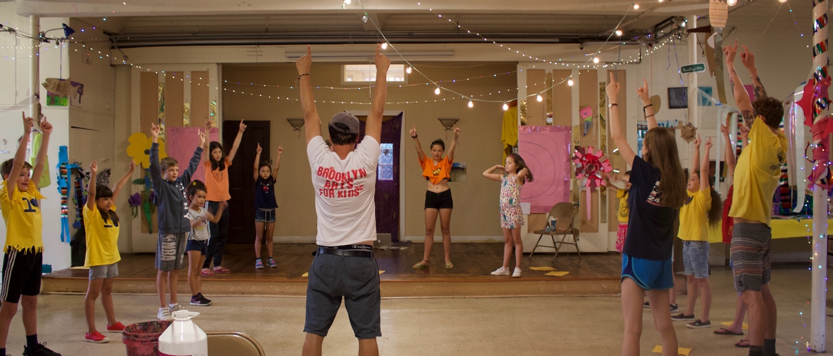

GET READY TO HAVE FUN
IN 2023!

___________ & ___________
are going to make a scene!

JFF!!

